HDMI Spec Notes

Signal Information
Describing the source of signals and basic information about their functions
- +5V sent from the source whenever it’s using the DDS or TMDS signals
- DDS Channel (I2C Channel, meeting specs version 2.1 section 15 for standard mode):
  - SDA, SCL, DDC/CEC GROUND
- CEC Line:

Operating Modes
- Video Data Period
  - Pixels of an active video line are transmitted
  - This means a literal horizontal line on the monitor
  - TMDS for 8 bits per channel per clock period, 24 bits total per pixel
- Data Island Period
  - Audio and auxiliary data transmitted as a series of packets
  - 4 bits per channel per clock period, 12 bits total
- Control Period
  - No video, audio, or auxiliary data needs to be transmitted
  - Required between any two non-control periods
  - Transition maximized encoding
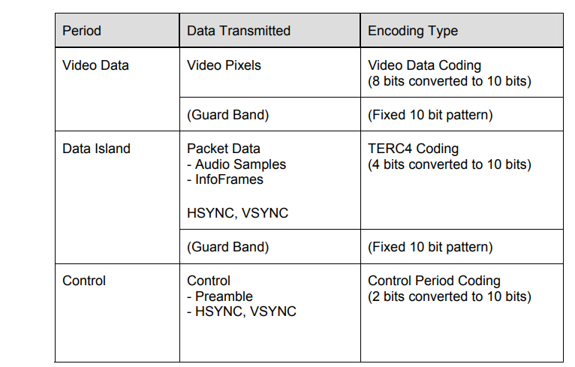

Control Period
Transmits the Preamble and allows the sink to perform character synchronization

There are two preamble encodings:
- Video Data Period: CTRL(0:3) = 1000
- Data Island Period: CTRL(0:3) = 1010

Synchronization:
- The control period uses transition-maximized encodings, which makes it useful for the sink to synchronize
- Necessary because the pixel clock DOES NOT exactly match the speed of transmissions. Different modes could run at 2x, 4x, etc. Need a counter for synchronization to know how to line up with the pixel clock

Video Data Period
Two character Video Leading guard band with predefined values. No trailing guard band. After leading, 24 bits of pixel information are transmitted every tmds clock period.
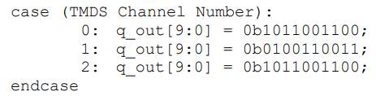

Repeater
A Repeater is defined as a device with one or more HDMI inputs, one or more HDMI outputs, and a retransmission function.
- This is what I’m making
- Each input device shall fulfill all requirements of an HDMI sink, each output all requirements of a source

